 | ASIA PACIFIC INSTITUTE OF INFORMATION TECHNOLOGY | 

Title of the Assignment –
Cyber Operations Report: Attack Simulation, Wireshark Evidence & Controls
ASSIGNMENT 8
Name and Student ID -

Course Name and Code – Cyber Operations, COCS71153

Instructor's Name –

Date of Submission – 11th of October 2025

Word Count – 3107

Table of Contents
Table of Contents ii
Table of Figures iii
Table of Tables iii
Introduction 1
Part A 1
A.1 Man In The Middle Attack (MITM) 1
A.1.1 Attack Explanation 1
A.1.2 Control Mechanisms and Mitigation Strategies 2
A.1.2.1 Implement Strong Encryption Protocols 2
A.1.2.2 Secure Wi-Fi Practices 2
A.1.2.3 Using DNSSEC 2
A.1.2.4 HTTP Public Key Pinning (HPKP) 3
A.2 Denial of Service Attack (DOS) 3
A.2.1 Attack Explanation 3
A.2.2 Control Mechanisms and Prevention Methods 4
A.2.2.1 Content Delivery Network (CDN) 4
A.2.2.2 Traffic Filtering and Rate Limiting 4
A.2.2.3 Behavioral Analysis with Machine Learning 4
A.3 SQL Injection Attack 5
A.3.1 Attack Explanation 5
A.3.2 Control Mechanisms and Prevention Methods 5
A.3.2.1 Allow-list input validation 5
A.3.2.2 Parameterised statements 6
A.3.2.3 Implementing Least Privilege 6
A.4 Zero-day Exploit Attack 6
A.4.1 Attack Explanation 6
A.4.2 Control Mechanisms and Prevention Methods 7
A.4.2.1 Use a web application Firewall (WAF) 7
A.4.2.2 Adopt a Zero Trust Security Model 7
A.5 DNS Tunnelling Attack 8
A.5.1 Attack Explanation 8
A.5.2 Control Mechanisms and Prevention Methods 9
A.5.2.1 Use DNS Security Extensions (DNSSEC) 9
A.5.2.2 Implement DNS traffic Analysis and Monitoring 9
A.5.2.3 Limit or Block Unneeded DNS Queries 10
Part B 10
B.6 Methodology 10
6.1 Statistical Overview 12
6.2 Network Mapping 12
6.3 Traffic Pattern Analysis 13
6.4 Security Filtering 13
6.5 Attack Identification 14
B.7 Port Scanning 14
B.8 ICMP flooding attack 16
B.9 SYN Flood attack 18
B.10 ARP Spoofing 20
Conclusion 22
References 22

Table of Figures

Figure 1 - Diagrammatic Explanation of a Man-in-the-Middle Attack 2
Figure 2 - An example of a DDoS attack 4
Figure 3 - An example of a SQL injection 5
Figure 4 - Timeline of a vulnerability lifecycle and the zero-day window of exposure 7
Figure 5 - An example of a DNS tunnelling Attack 9
Figure 6 - The overall methodology to identify attacks 11
Figure 7 - Demonstration of the Port scanning attack 15
Figure 8 - Diagram on the attack pattern 16
Figure 9 - Demonstration of an ICMP Flooding attack 17
Figure 10 - Demonstration of a SYN flood attack 18
Figure 11 - Comparison of attacker and victim packets 19
Figure 12 - Demonstration of an ARP spoofing attack 20
Figure 13 - An arp request chart with respect to the time 21

Table of Tables

Table 1 - Wireshark statistical overview 12
Table 2 - Network mapping in Wireshark 12
Table 3 - Traffic pattern analysis in Wireshark 13
Table 4 - Security filters for common attacks 13
Table 5 - Network Attack Identification 14

Introduction
The widespread use of the internet has increased the risk of cyber-attacks targeted towards internet users and organizations. In the digital age, data is the most important asset; therefore, cyber attackers are targeting the data of organizations and individuals as well. This report discusses four main attacks and provides an overall idea of the attack. Further the attack impacts and mitigation strategies will be discussed as well. In the second part of the report a Wireshark file will be analyzed and four attacks that has been occurred will also be discussed

Part A

A.1 Man In The Middle Attack (MITM)

A.1.1 Attack Explanation
A man-in-the-middle attack is a scenario where the attacker has intruded on a secure communication between two parties. Altering or gathering information shared between two parties. The two parties believe they are communicating with each other, but in reality, an attacker is in the middle of the conversation. The attackers in some instances could intercept the message passing between and inject or alter the messages. Further, an MITM attack can succeed only if an attacker has been able to sufficiently satisfy both parties' expectations. (Javeed and MohammedBadamasi, 2020)
Below are some of the major types of man-in-the-middle attacks and a brief explanation

- HTTPS Spoofing - The attacker tricks the victims into believing that the connection is secure by replacing a fake SSL/TLS certificate

- Session Hijacking - Uses the session cookies and tokens to impersonate a real user in an active session

- MITM Wi-Fi - a fake wifi hotspot is used to manipulate or intercept real-time communications

- Email Hijacking - the emails are intercepted and used to steal sensitive information

- ARP spoofing - the attacker sends out a fake ARP request to the network with the attacker’s MAC address with a target IP, and then intercepts local network traffic

As seen above, these types of attacks could fall into application-to-application communications or even user-to-user or user-to-application communications. Below is a diagrammatic example of how an MITM attack would be carried out

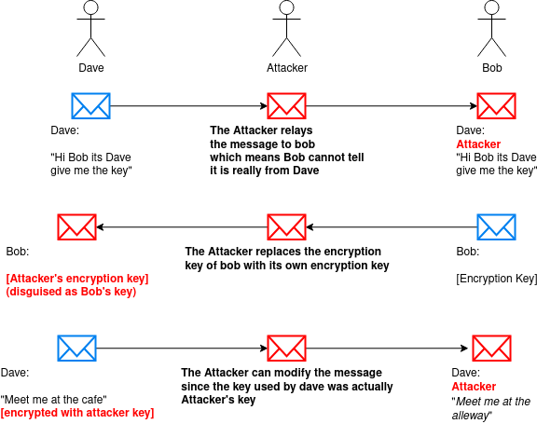
Figure 1 - Diagrammatic Explanation of a Man-in-the-Middle Attack

A.1.2 Control Mechanisms and Mitigation Strategies

A.1.2.1 Implement Strong Encryption Protocols

Implementing Transport Layer Security (TLS) secures and encrypts the data transmitted which making it difficult for attackers to intercept. However, it is crucial to use updated versions of SSL/TLS and use strong cyphers.

A.1.2.2 Secure Wi-Fi Practices
Avoiding public or any unsecured Wi-Fi can prevent attackers from intercepting data further. Using WPA3-encrypted Wi-Fi networks is essential as well. Additionally, disabling auto-connect features and verifying the legitimacy of networks can also be used. (Aliyu, Sheltami and Shakshuki, 2018)

A.1.2.3 Using DNSSEC

DNS spoofing attacks could be prevented by using DNSSEC, which uses signatures to authenticate DNS records, preventing users from being directed to malicious IPs

A.1.2.4 HTTP Public Key Pinning (HPKP)

Helps prevent MITM attacks where the certificate authority is itself compromised. During the first transaction by having the server provide a list of “pinned” public key hashes, subsequent transactions then require one or more of the keys in the list in order to authenticate he transaction. (Diaz-Sanchez et al., 2019)

A.1.3 Attack demonstration
The Ettercap tool was used in the attacker VM and the victim VM(192.168.100.104) is connected with a server(192.168.100.101)
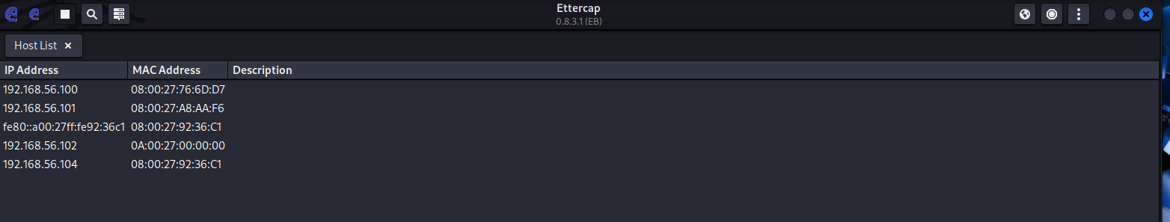
Figure A.1.3.1: The available hosts are shown
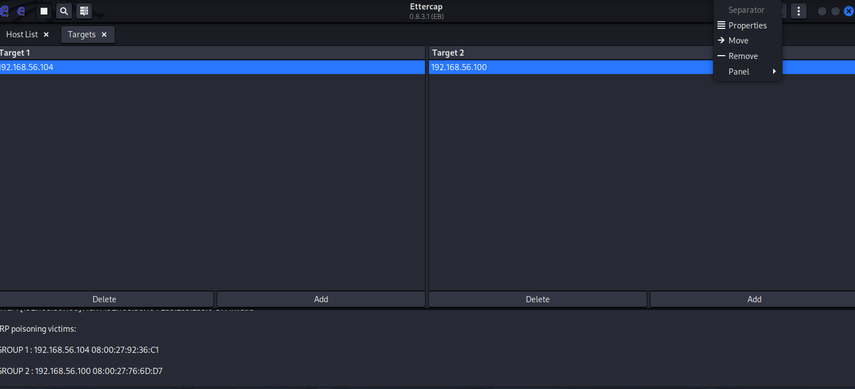
Figure A.1.3.2: ARP poisoning was selected in order to conduct the attack by the blow logs the attack is happening. Wireshark was used to capture the traffic of eth1 and the victim pinged the server and accesed a website of the server
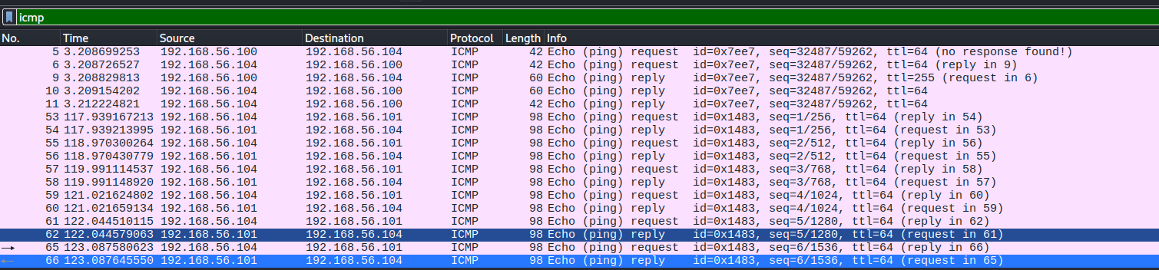
Figure A.1.3.3 : ICMP messages sent from the victim to the server can be seen here
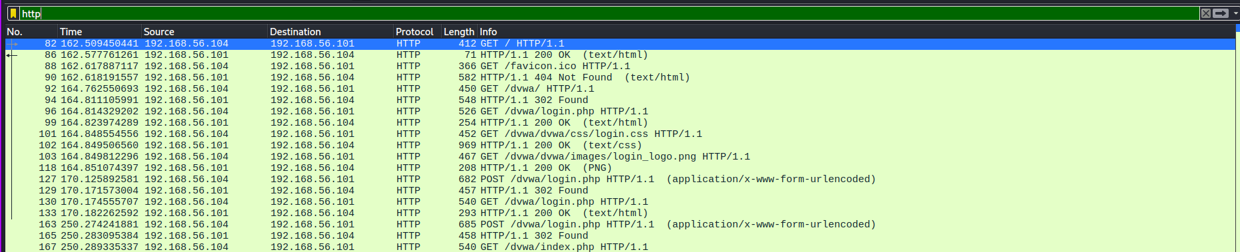
Figure A.1.3.4 : HTTP messages sent from the victim to the server can be seen here

A.2 Denial of Service Attack (DOS)

A.2.1 Attack Explanation
Denial of service (DOS) attacks intend to make the resources unavailable to their users or clients. These attacks make the network resources unavailable by disrupting the network, flooding the targeted machine or resource with a large number of requests to the point of a breakdown, which would prevent legitimate requests from being processed. The range of attacks is widespread; it could be a server of a million requests or a computer on an internal network. Below are some of the types of Attacks carried out

- Smurf Attack - Malicious actors use the broadcast addresses of vulnerable networks by sending spoofed packets (www.researchpublish.com, n.d.), which results in the flooding of a targeted IP address.

- Ping flood - This attack overloads the targeted resource with ICMP packets by giving more pings than it is able to handle, which would result in DOS

- Ping of Death - This is often correlated with a ping flood attack. A ping of death attack sends a malformed packet to a targeted resource, resulting in system crashes

DDoS attacks are a more advanced version of DOS attacks, where the incoming flooding of the victim originates from multiple different sources, making the mitigation harder.

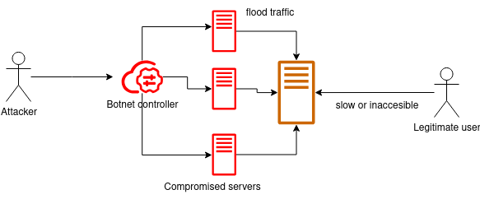
Figure 2 - An example of a DDoS attack

A.2.2 Control Mechanisms and Prevention Methods

A.2.2.1 Content Delivery Network (CDN)

CDNs distribute the services and contents across different servers across the world, making it harder to attack a single server. Furthermore, the DNS solutions provide DDoS mitigation services, which help protect against large-scale traffic surges caused by DDoS attacks (Shobiri, Mannan and Youssef, 2022). CDNs are able to distribute traffic across multiple servers (load balancing), which reduces the impact on one server. Cloudflare and Akamai are services which offer CDNs.

A.2.2.2 Traffic Filtering and Rate Limiting

Firewalls and intrusion detection systems (IDS) can be used to detect and filter malicious traffic. These systems can be configured to recognize abnormal traffic patterns associated with DoS and DDoS attacks. Further rate limiting can be used to limit the number of requests a user can make to a server within a given period. Cloudflare and AWS Shield provide rate-limiting solutions

A.2.2.3 Behavioral Analysis with Machine Learning

Behavioral analytics can monitor traffic for unusual patterns such as sudden surges of traffic or irregular request types. ML algorithms can be used to detect emerging attacks. Radware Defense, Akamai Kona site defender and Cloudflare are some of the services which use behavioral analysis to detect DoS attacks.

A.2.3 DoS Attack Demonstration
A VM machine(victim) - 192.168.56.104 was used and the attacker was a Kali vm with an IP of 192.168.56.102
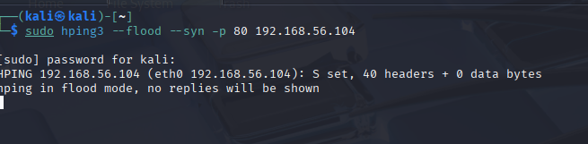
Figure A.2.3.1: The attack was conducted using the hping3. The DNS attack type was a SYN Flood attack
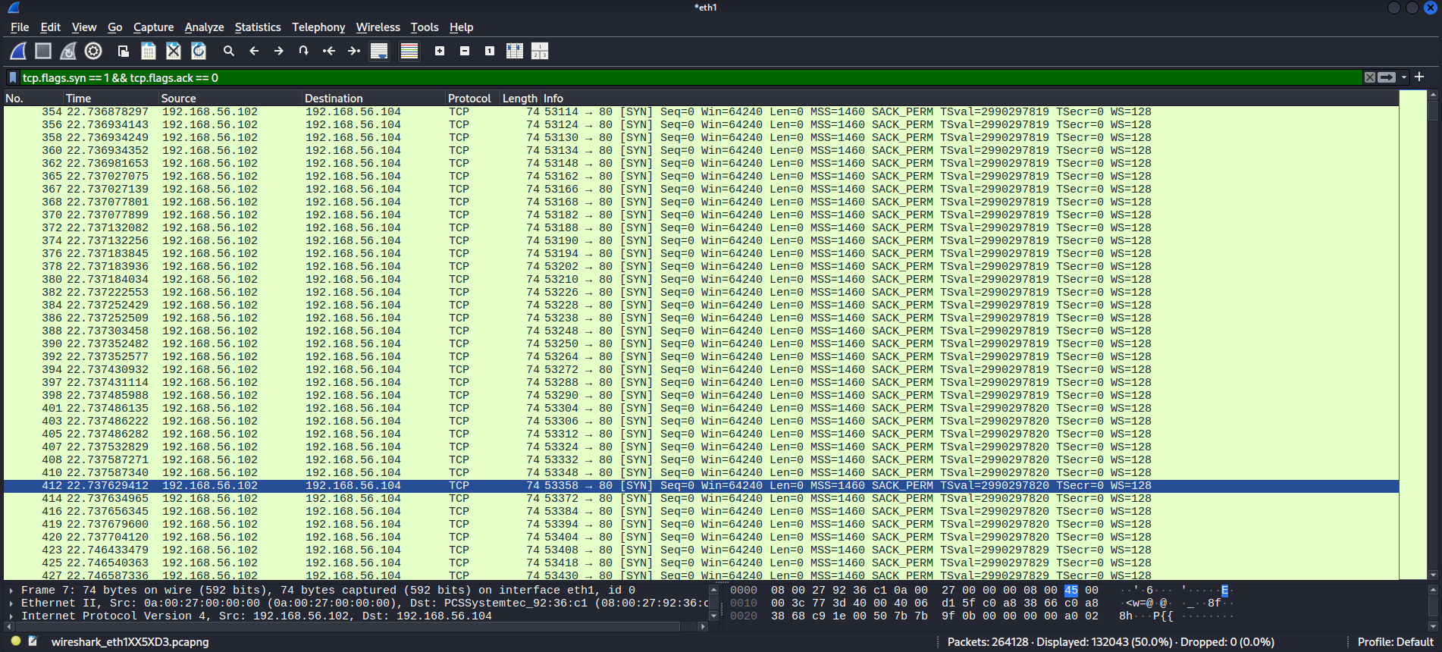
Figure A.2.3.2: The above were the captured Wireshark packets. Here, the SYN packets without ACK messages are shown. A total of 264128 packets have been sent, which clearly indicates the success of the attack

A.3 SQL Injection Attack

A.3.1 Attack Explanation
SQL injection is a special type of attack where the software vulnerabilities in data entry fields are used to gather data from the databases. Malicious SQL statements are inserted into an entry field for execution to dump database contents to the attacker. In general, applications which use SQL and have a traditional architecture are highly targeted by these types of attacks. These types of attacks tamper, destroy or read existing data from the database. Even document-based databases could be attacked as well.

According to the OWASP Top 10 Web Application Security Risks the injection is the third most common type of attack. 94% of the analyzed applications had software vulnerabilities which allow SQL injection. These vulnerabilities occur when the applications process untrusted data as a SQL query, allowing attackers to execute malicious commands. (OWASP, 2025)

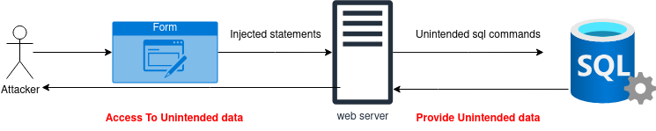
Figure 3 - An example of a SQL injection

Below are the types of SQL injection attacks which can be identified
- Error Based SQL injection
- Boolean based Blind SQL injection
- Time based blind SQL injection
- Union based SQL injection

A.3.2 Control Mechanisms and Prevention Methods

A.3.2.1 Allow-list input validation
Allow-list is a type of input validation which rejects all invalid inputs and only allows valid inputs. This method is applicable for structured data, such as dates or email addresses, where strict data validation rules can be applied.

A.3.2.2 Parameterized statements
Most of the development platforms support parameterized statements. These are also known as bind variables. These variables only hold the value of a defined type, which prevents any query structure changes.

A.3.2.3 Implementing Least Privilege
The permissions to access the database must be granted only to essential endpoints.Access Tables and user roles can be used to implement permissions, which would make the SQL attacks harder since the application itself has been granted minimal permissions. (Billoir et al., 2023)

A.3.3 SQL Injection Attack Demonstration
The attacks were done using the Metasploitable tool and Burp Suite software
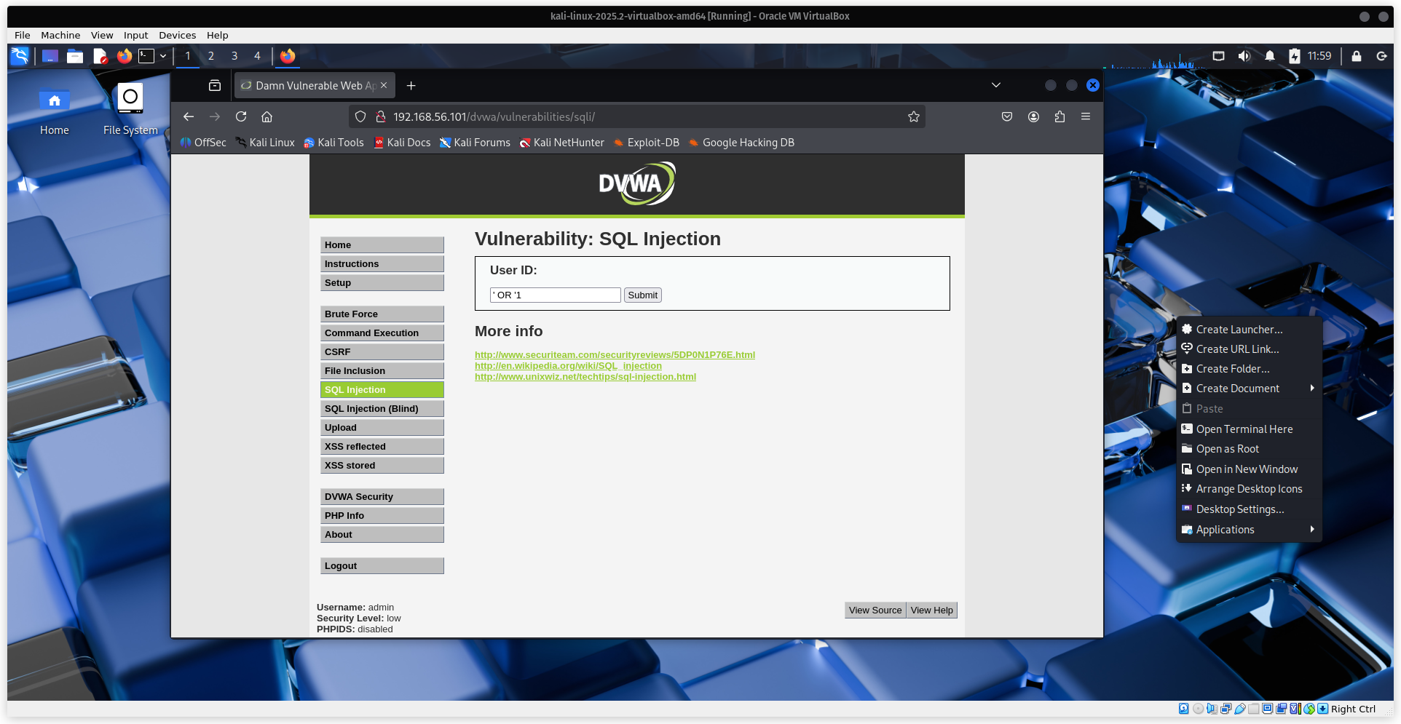
Figure A.3.3.1: This website represents a traditional website with a simple form. By adding the above bypass code, SQL injection can be done (Victim IP - 192.168.56.101)
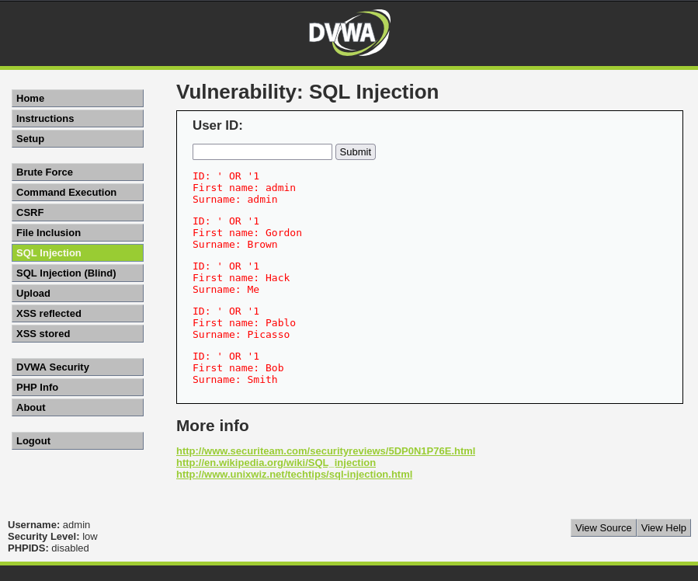
Figure A.3.3.2 : The above is the output It has laid out all the information of the users because of the attack
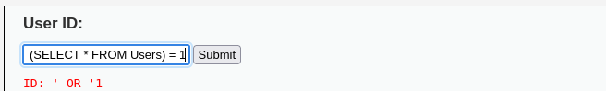
Figure A.3.3.3 : Further pybasses can be done here is an example of another SQL query
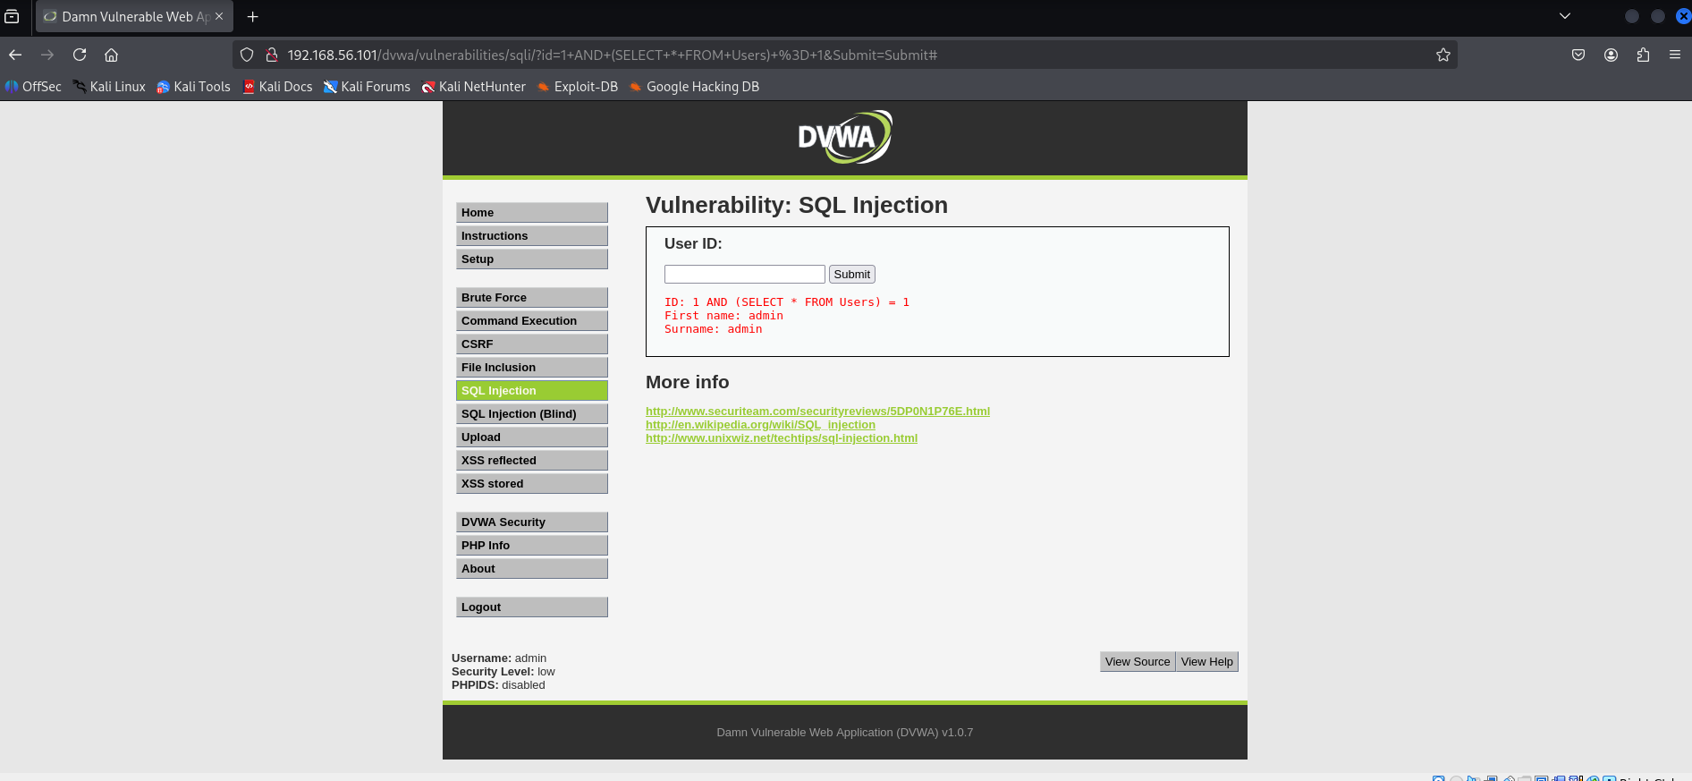
Figure A.3.3.4 : The output of the above command

A.4 Zero-day Exploit Attack

A.4.1 Attack Explanation
A zero day is known as a software vulnerability or a loophole in the code which has not been discovered by developers or anyone capable of fixing it. Until the vulnerability is fixed, any malicious party can exploit that vulnerability to harm the systems. there event of a threat actor exploiting an undiscovered loophole or a vulnerability is known as a zero-day attack. A zero-day attack can occur when the hacker releases malware to exploit the software vulnerability before the software developer has patched the loophole. (Kumar, 2014)

These attacks are often sophisticated and are able to bypass the security measures already in place. No immediate defense measures can be taken since the existence of a vulnerability is unknown to the users and developers. Therefore, the attackers have a head start, and the systems are vulnerable until the exploit is discovered and a patch is released.

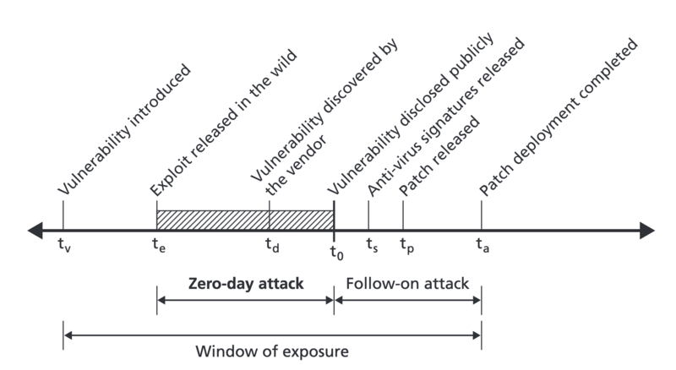
Figure 4 - Timeline of a vulnerability lifecycle and the zero-day window of exposure

Source: Adapted from Libicki et al. (2015), The Defender’s Dilemma: Charting a Course Toward Cybersecurity. RAND Corporation. Public Domain. Available at: https://commons.wikimedia.org/w/index.php?curid=147095222

As shown in Figure 4.1 (Libicki et al., 2015), the zero-day window represents the time a vulnerability can be exploited before patches are applied.

A.4.2 Control Mechanisms and Prevention Methods

A.4.2.1 Use a web application Firewall (WAF)

A web application firewall is a security device which is designed to filter, monitor and analyze HTTP/HTTPS traffic between the web application and the internet. Further, a WAF can be used as a reverse proxy as well, shielding the application from malicious requests before they reach the application.

A.4.2.2 Adopt a Zero Trust Security Model

A zero-trust security model operates on the principle of never trust, always verify. The zero-trust model assumes that attacks could be from an external or an internal entity. Zero trust minimizes the potential impact of zero-day vulnerabilities since even if an attacker exploits a flow, a highly controlled environment can prevent the damage.

A.4.3 Zero-Day Attack demonstration
The tools of NMAP Metasploitable and kali linux was used
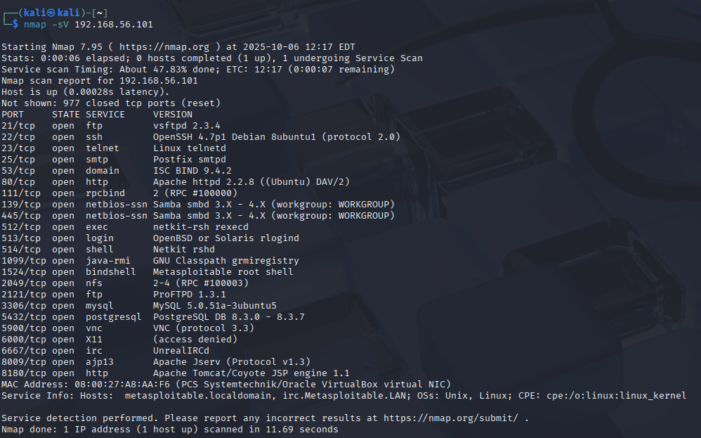
Figure A.4.3.1. : Nmap was used to find the open ports and services there is a vulnerability in vsftpd 2.3.4 which allows an attacker to gain a shell with a simple connection using Metasploit
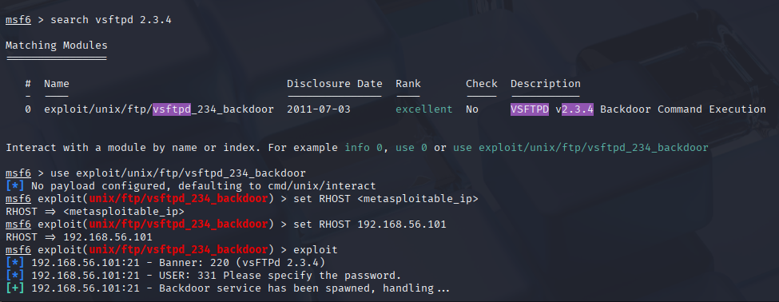
Figure A.4.3.12 : using the msfconsole the vulnerability is found then It can be exploited once sucessful the attack has access to the victim’s computer in a shell
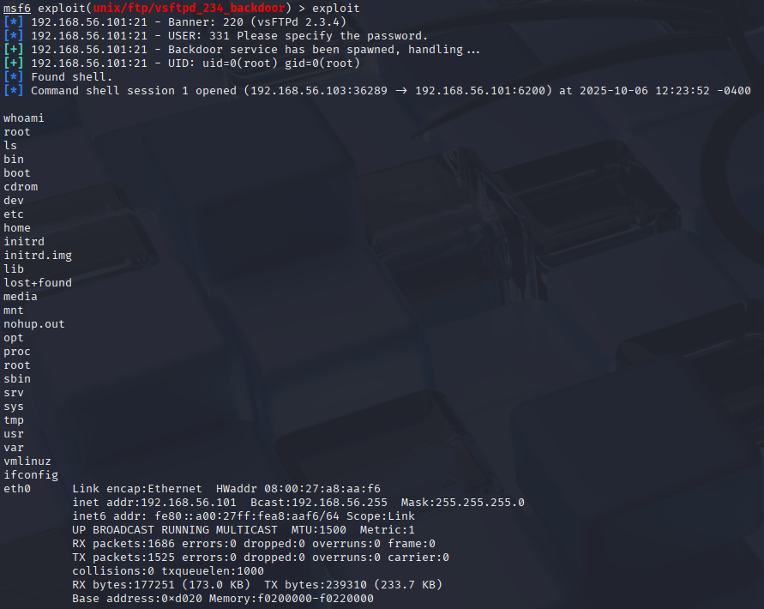
Figure A.4.3.3. As seen by the above screenshot, the victim is now vulnerable, which can be seen by the commands conducted above

A.5 DNS Tunnelling Attack

A.5.1 Attack Explanation
DNS Tunnelling is a type of attack that allows hackers to bypass network security by using the Domain Name System. The DNS is used to send malicious traffic by hiding non-DNS traffic inside DNS packets. Attackers could bypass network filters since the packets would be disguised as DNS packets.

Below are some of the different types of tunnelling attacks

- Command and control tunnelling - This uses a DNS protocol to create a backchannel for command and control communications. Attackers are able to send commands to the victim devices and receive updates.(Wang et al., 2021)

- Data exfiltration - Attackers can use DNS tunnelling in order to move the data out from a secure environment. Sensitive information can be injected and hidden inside the DNS packets.

- Malware delivery and staging - DNS tunnelling can be used to deliver additional malware payloads to the victim system. Which would help in keeping control over the system.

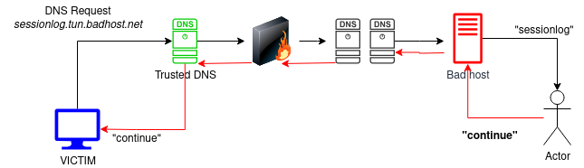
Figure 5 - An example of a DNS tunnelling Attack

Step by step explanation of how DNS Tunneling works

- Attacker register a domain
- Attacker infects a computer
- Client sends a DNS query
- Query reaches DNS resolver
- Attacker’s server decodes the request
- Sever encodes a response
- Client receives and decodes the response
- Process repeats

A.5.2 Control Mechanisms and Prevention Methods

A.5.2.1 Use DNS Security Extensions (DNSSEC)

DNSSEC adds a layer of security to DNS queries by ensuring that the responses have not been tampered with. Even though DNSSEC does not directly prevent DNS tunnelling, it can make it more difficult for attackers to manipulate DNS records making tunnelling attacks harder to carry out.

A.5.2.2 Implement DNS traffic Analysis and Monitoring

Regular monitoring and analysis, looking out for unusual high query rates, obscure query names, or non-standard sports, could help in preventing DNS Tunnelling attacks.Tools like Suricata, Zeek and DNS sinkhole are some of the tools which can be used to detect suspicious DNS requests(Yadav et al., 2012)

A.5.2.3 Limit or Block Unneeded DNS Queries

Blocking or limiting the unnecessary requests coming to the servers can reduce the attack surface for DNS tunnelling. DNS queries can be blocked if they are referencing non-existent domains. Further, DNS query rate can also be reduced from a single source; DNS servers can also be configured to reject queries including TXT or NULL records, which are usually used for DNS tunnelling.

A.5.3 DNS Tunneling Attack Demonstration
The tools have been used in a separate VM DNS server with iodine, and in the Keli machines, also with iodine.This is a lab setup of how a DNS tunnel can be created
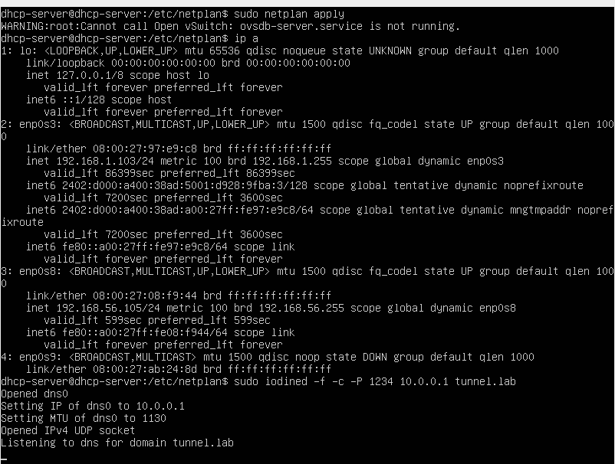
Figure A.5.1 : DNS server is now connected with the kali VM
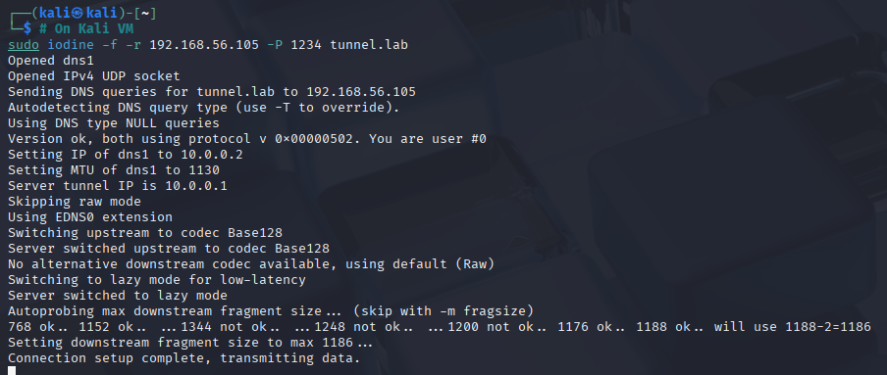
Figure A.5.2: VM is now connected to the DNS tunnel
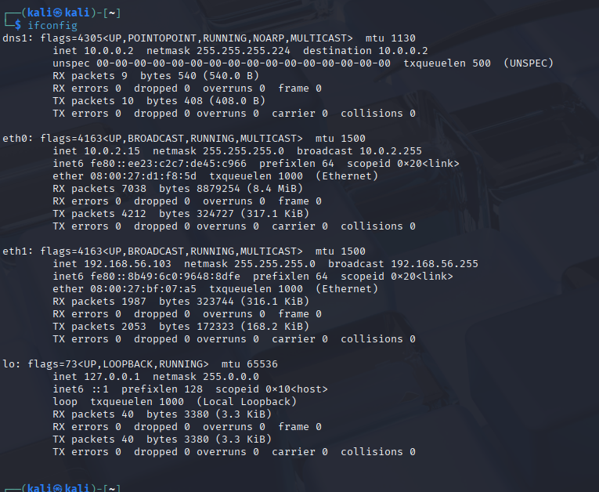
Figure A.5.3: As seen here, a DNS tunnel has been created by this tunnel, and any SSH commands or data-stealing commands can be carried out

Part B

B.6 Methodology

This analysis follows an approach where, in the beginning, a high-level statistical overview will be provided, then focuses on specific types of attacks and how to find them using features like Wireshark filters.
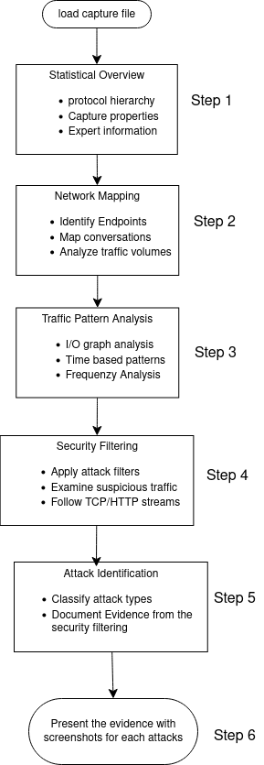
Figure 6 - The overall methodology to identify attacks

6.1 Statistical Overview
This step aims to understand the overall traffic data and get a broader picture

Table 1 - Wireshark statistical overview
Step | Wireshark Command | Goal
Protocol Hierarchy | Statistics→Protocol Hierarchy | To view protocol distribution percentages
Capture properties | Statistics →Capture file properties | Get the file duration and packet count
Expert information | Analyse → Expert Information | To identify automatic warnings and any anomalies

6.2 Network Mapping
This maps the network topology and hosts

Table 2 - Network mapping in Wireshark
Step | Wireshark Command | Goal
Identify Endpoint | Statistics→Endpoints → IPV4 | IP addresses packet counts
Map conversations | Statistics → Conversations → IPv4 | Communication pairs
Analyse Traffic Volume | Sort conversations by the bytes column | Get active communication pairs

6.3 Traffic Pattern Analysis
This detects unusual traffic patterns and timing

Table 3 - Traffic pattern analysis in Wireshark
Step | Wireshark Command | Goal
I/O graph analysis | Statistics→I/O graphs | Traffic volume spikes and patterns
Frequenzy analysis | Sort packet list by time column | Identify rapid attack sequences

6.4 Security Filtering
These are the filters which are applied to detect common attack patterns

Table 4 - Security filters for common attacks
Attack | Syntax | Purpose
Port Scanning | - tcp.flags.syn == 1 && tcp.flags.ack == 0 | Identify reconnaissance activities
Icmp Flooding | - icmp  - ip.src == x.x.x.x and icmp.type == 8 | Detect flooding attacks from a certain suspected attacker
SYN flood attacks | - ip.src == x.x.x.x and tcp.flags.reset == 1  - tcp.flags.reset == 1 | To identify whether TCP Flooding
ARP spoofing | - arp.opcode == 2  - arp  - arp.duplicate-address-detected | Detect man-in-the-middle attempts

6.5 Attack Identification

Table 5 - Network Attack Identification
Step | Focus Area | Wireshark command
Packet level examination | Individual packet inspection | Click packet → examine middle pane
Payload investigation | Application data content | View hex dump in bottom pane

After following the above four attacks were identified, the details will be discussed in the sections below.

B.7 Port Scanning

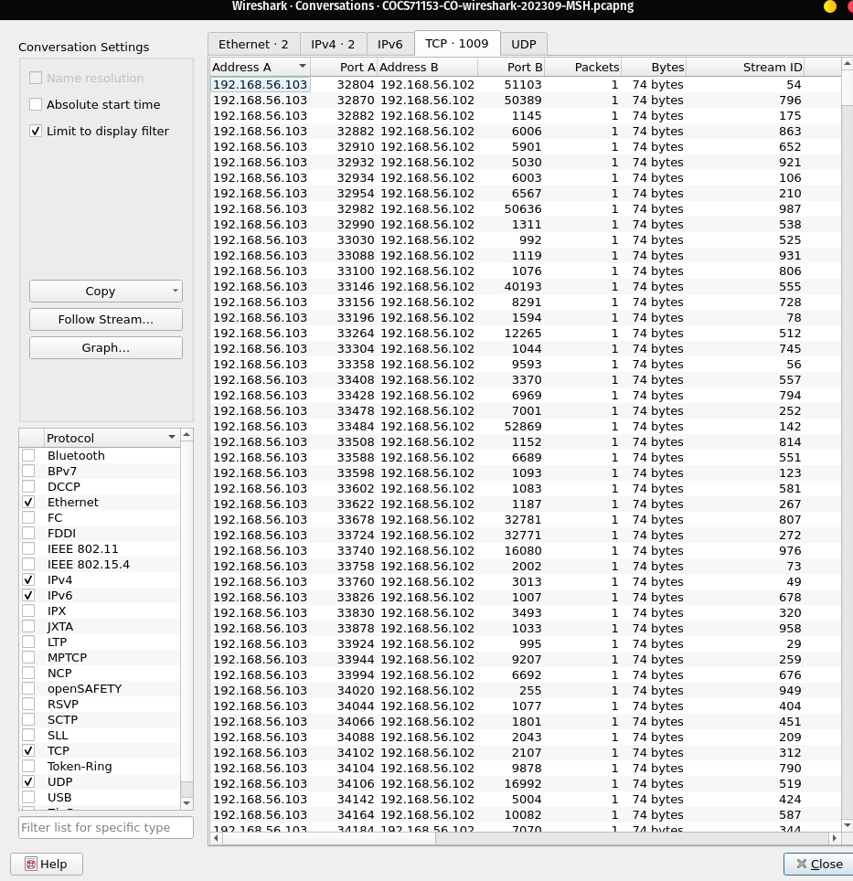
Figure 7 - Demonstration of the Port scanning attack

- The above screenshot was taken when the tcp.flags.syn == 1 && tcp.flags.ack == 0 filter was used. And then using the Statistics->conversations->UDP tool was used
- According to the information shown above the source port changes for each session and the destination port (port B) is always a different port
- Packets per connection and bytes per connection is low
- Further, no packets from B->A which means no responses
- The destination ports are highly varied which covers a wide span of ports
- Below is a diagram explaining what has happened

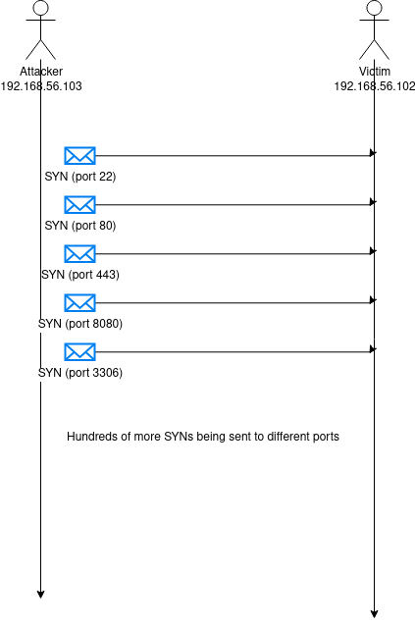
Figure 8 - Diagram on the attack pattern

The above evidence shows clearly that an attempt to port scanning has occurred since this pattern matches a TCP SYN scan which is trying to find open ports of the victim

B.8 ICMP flooding attack

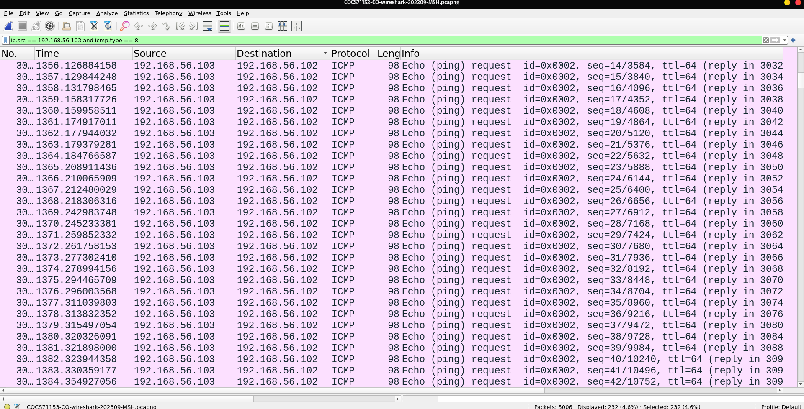
Figure 9 - Demonstration of an ICMP Flooding attack

- The above screenshot was taken when the ip.src == 192.168.56.103 and icmp.type == 8 filter was used
- There is a steady and a rapid sequence of ICMP Echo requests from 192.168.56.103 to 192.168.56.102
- ICMP packets are being sent a nearly once per second, with a sudden increase of sequence numbers, which indicates that this attack is an automated flood rather than manual pings
- Each packet has a consistent size (98 bytes) and a TTL(64), indicating automated scripting
- The volume of the pings go far beyond typical diagnostics, which only sends a handful of packets

B.9 SYN Flood attack
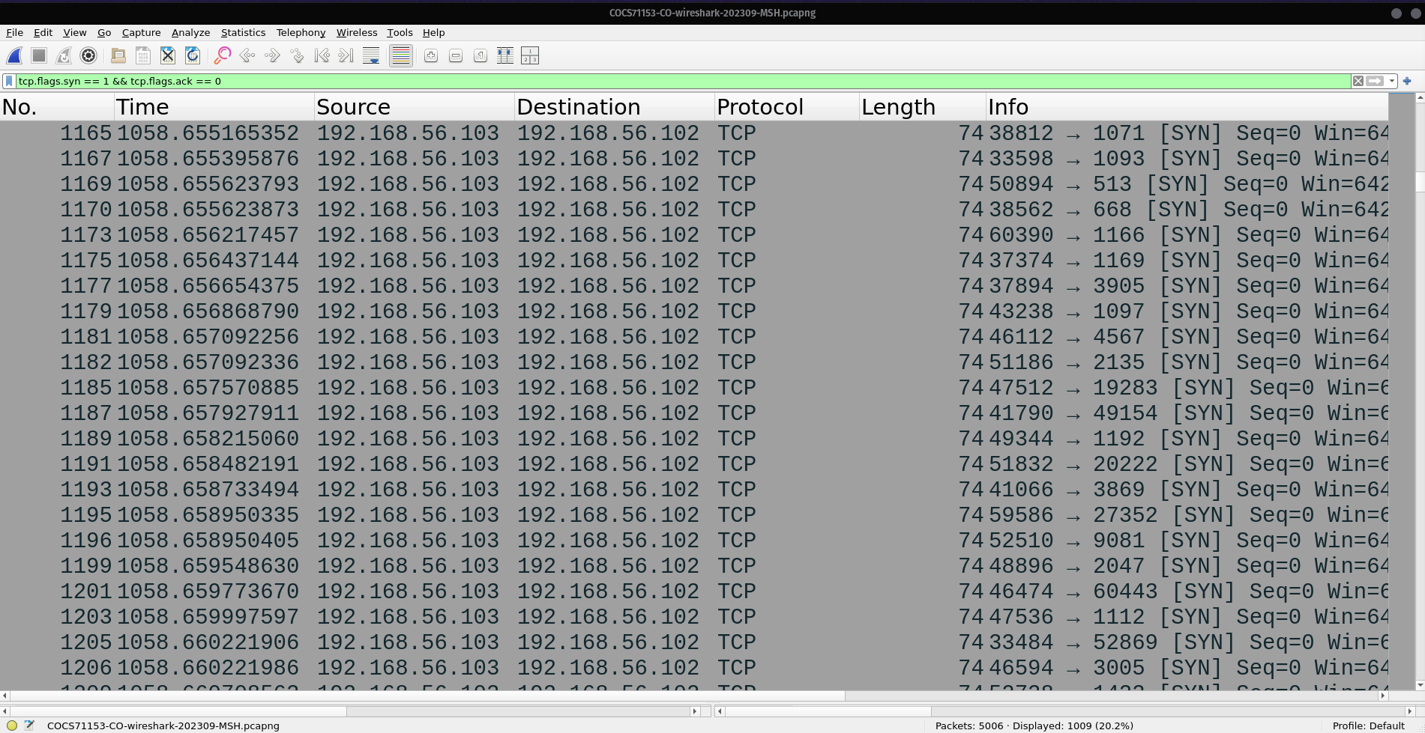
Figure 10 - Demonstration of a SYN flood attack

- The above screenshot was taken when the tcp.flags.syn == 1 && tcp.flags.ack == 0 filter was used.
- According to the above screenshot, there is a large amount of SYN packets being sent without any ACK responses.
- All SYN packets have been sent within milliseconds, suggesting an attempt to exhaust server resources
- All the SYN packets have been sent to 192.168.56.102 from 192.168.56.103
- When statistics → Conversations → IPV4 was executed, the result is a graph representing the results
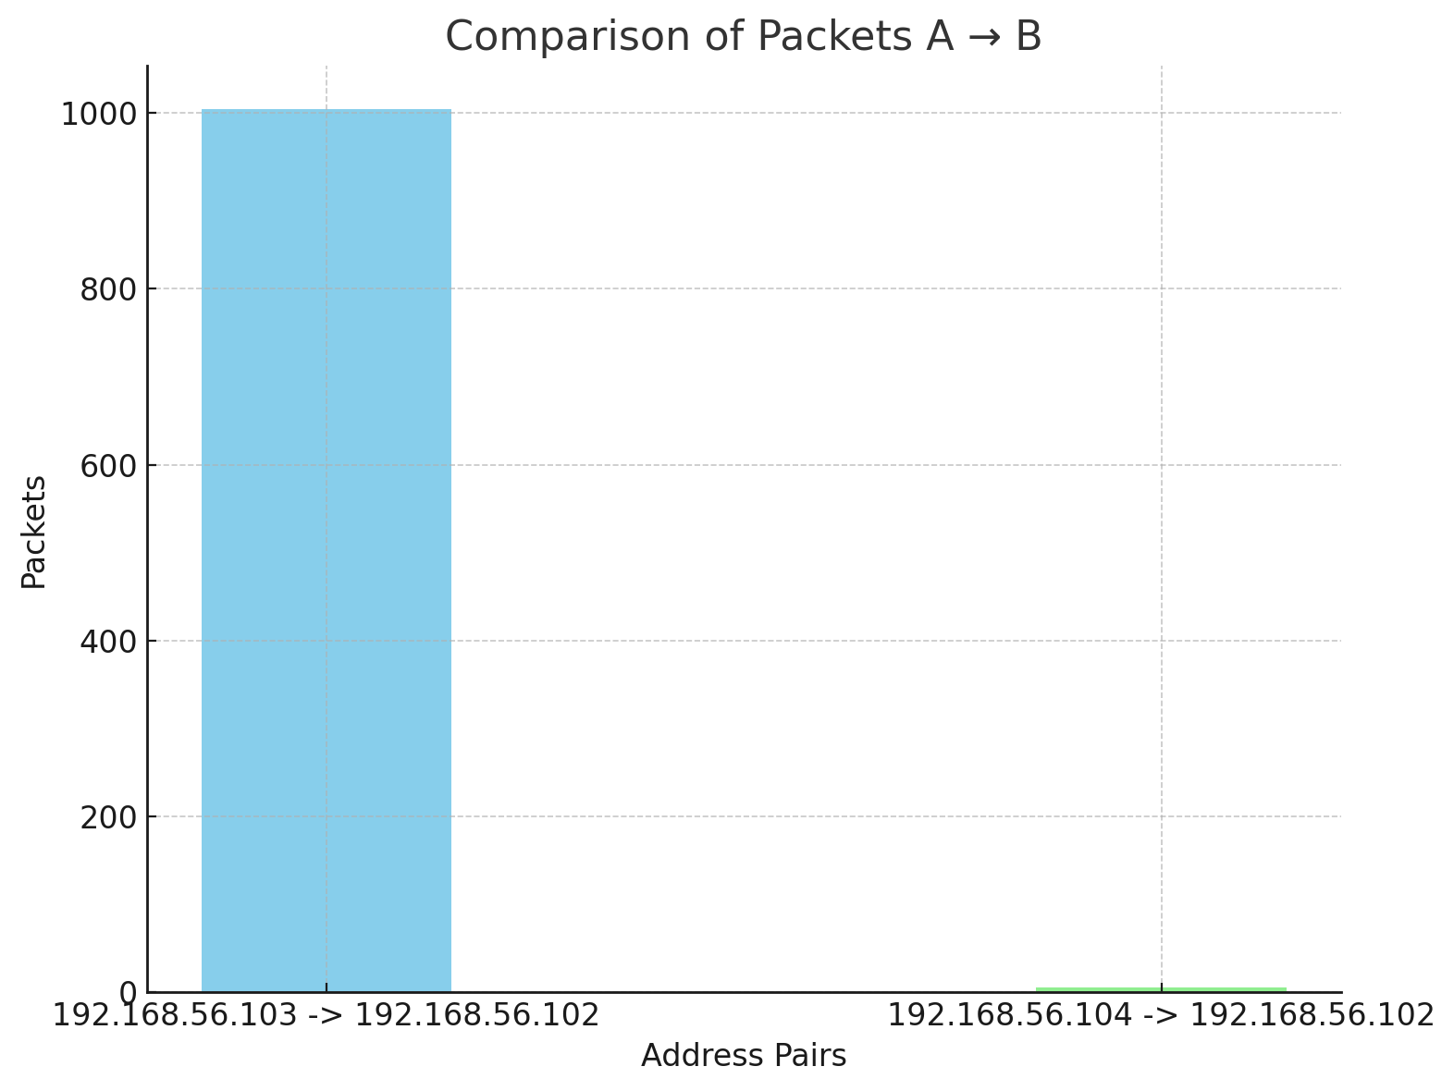
Figure 11 - Comparison of attacker and victim packets
- A substantial number of packets (1004packets) from 192.268.56.103 have been sent to 192.168.56.102, while the communication from 192.168.56.104 has only five packets, showing a normal transaction
- This shows clearly that there has been an attempt at a DoS attack
- The lack of ACK responses suggests that the attacker does not care about the completion of the handshake.

B.10 ARP Spoofing

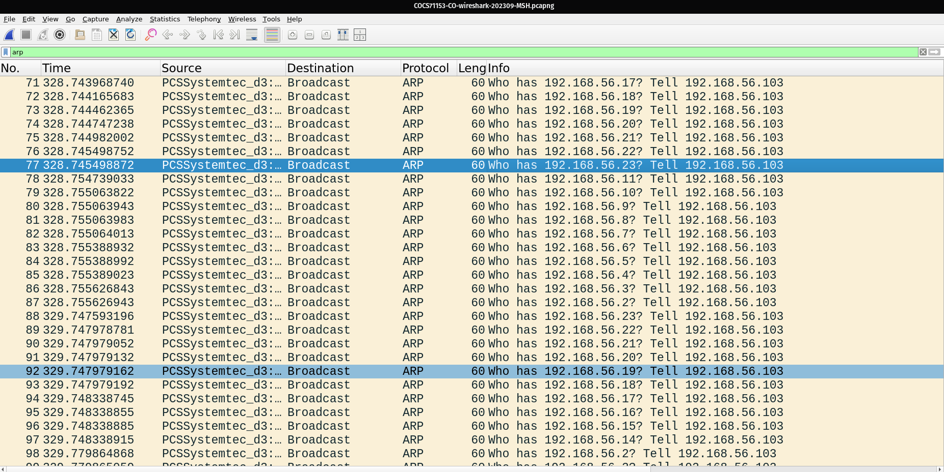
Figure 12 - Demonstration of an ARP spoofing attack

- The above screenshot was taken when an arp filter has been used on the packet
- According to the screenshot a lot of ARP broadcasts has happened with frequent unsolicited ARP replies
- The source has been asking all types of combinations of the IP and trying to get the mac addresses
- All the arp Requests have been sent by the suspected attack ip of 192.268.56.103 in a short amount of time.
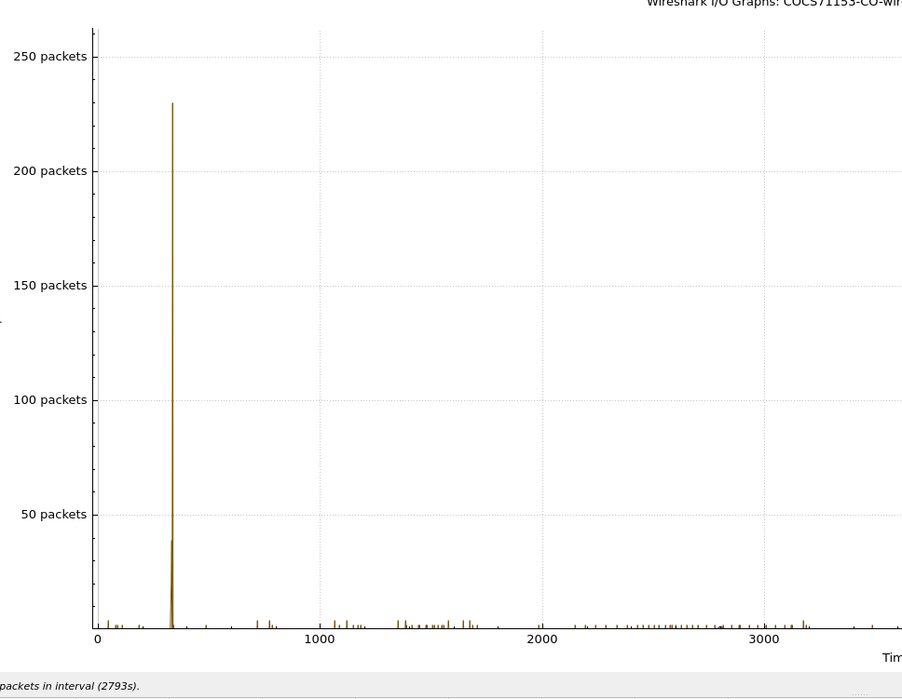
Figure 13 - An arp request chart with respect to the time

- According to the above graph the requests has been sent on a short time period almost at the same time with the changes of milliseconds
- In conclusion this can be identified as an attempt to do ARP spoofing, possibly to launch a man in the middle attack.

Conclusion

The above report discussed four types of cyber-attacks. Further a comprehensive mitigation strategy was provided as well. These attacks can be avoided by following proper security practices and implementing new technologies. Then the report discussed the methodologies to identify network activity from Wireshark. And the report provided 4 attacks which seems to have happened.

References
- Javeed, D. and MohammedBadamasi, U. (2020). Man in the Middle Attacks: Analysis, Motivation and Prevention. International Journal of Computer Networks and Communications Security, 8(7), pp.52–58.

- Aliyu, F., Sheltami, T. and Shakshuki, E.M. (2018). A Detection and Prevention Technique for Man in the Middle Attack in Fog Computing. Procedia Computer Science, 141, pp.24–31. doi:https://doi.org/10.1016/j.procs.2018.10.125.

- Diaz-Sanchez, D., Marin-Lopez, A., Mendoza, F.A., Cabarcos, P.A. and Sherratt, R.S. (2019). TLS/PKI Challenges and Certificate Pinning Techniques for IoT and M2M Secure Communications. IEEE Communications Surveys & Tutorials, 21(4), pp.3502–3531. ‌

- www.researchpublish.com. (n.d.). Research Publish Journals. [online] Available at: https://www.researchpublish.com/upload/book/A%20Study%20of%20DOS%20DDOS-903.pdf.

- Shobiri, B., Mannan, M. and Youssef, A. (2022). CDNs’ Dark Side: Security Problems in CDN-to-Origin Connections. Digital Threats: Research and Practice. doi:https://doi.org/10.1145/3499428.

- ‌OWASP (2025). OWASP Top Ten. [online] owasp.org. Available at: https://owasp.org/www-project-top-ten/.

- Eddie Billoir, Romain Laborde, Ahmad Samer Wazan, Yves Rütschlé, Abdelmalek Benzekri. Implementing the Principle of Least Privilege Using Linux Capabilities: Challenges and Perspectives. 7th Cyber Security in Networking Conference (CSNet 2023), IEEE Communications Society, Oct 2023, Montréal, Canada. pp.130--136, ⟨10.1109/CSNet59123.2023.10339753⟩. ⟨hal-04278090⟩

- ‌Kumar, A. (2014). Zero Day Exploit. SSRN Electronic Journal. doi:https://doi.org/10.2139/ssrn.2378317.

- Wang, Y., Zhou, A., Liao, S., Zheng, R., Hu, R. and Zhang, L. (2021). A comprehensive survey on DNS tunnel detection. Computer Networks, 197, p.108322. doi:https://doi.org/10.1016/j.comnet.2021.108322.
- Yadav, S., Reddy, A.K.K., Reddy, A.L.N. and Ranjan, S. (2012). Detecting Algorithmically Generated Domain-Flux Attacks With DNS Traffic Analysis. IEEE/ACM Transactions on Networking, 20(5), pp.1663–1677. doi:https://doi.org/10.1109/tnet.2012.2184552.

- Libicki, M.C., Ablon, L. and Webb, M., 2015. The defender’s dilemma: Charting a course toward cybersecurity. RAND Corporation. Available at: https://www.rand.org/pubs/research_reports/RR1024.html [Accessed 30 September 2025].

